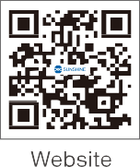

MC2
Multi-function Multimeter Camera Instruction Manual

MC2 Camera User Manual V1.0

catalogue

Product Introduction 2

System Menu 3

Introduction to the Left Menu 3

Introduction to the Upper Menu 4

System Operation Guide 4

Left Menu Button Guide 4

White Balance Menu 4

Exposure Menu 4

Color Adjustment Menu 5

Other Function Menu 5

Grid Line Menu 6

Storage Menu 6

Calibration Menu 6

3.1.8. Measurement Menu 7

3.1.9 Resolution Menu 7

Settings Menu 8

Multimeter Settings Menu 8

Upper Menu Button Guide 9

Photo button 9

Timed Photography Menu 9

Video button 9

Library Button 10

Freeze button 11

Four screen button 11

Magnification button 11

3.2.8. Magnification reduction button 11

Frequently Asked Questions 13 12

Note 13 12

- Product Introduction
·The MC2 is a multifunctional HDMI camera equipped with a 4K image processing system, which can be directly used for the acquisition of microscope videos and images. Its main features are as follows:
- Supports HDMI interface connection to external display, enables synchronous output, 4K/1080P HDMI output adaptive switching
- Supports both HDMI and USB output
- Powerful ISP, sharpening and noise reduction, ROI white balance more accurate
- Built-in professional measurement system
- New browsing interface, rich file manipulation functions, real-time image versus picture,
real-time image versus video
- S-Viewer software, which is more convenient to operate from the computer

Camera Usage Instructions
① HOLD key: Records the current multimeter data
② OFF/Channel key: Long press to power off, short press to switch the multimeter range
③ Power supply: 5V/2A Type-C power socket
④ PC: Connect to the PC via a data cable to transmit images in real time and operate in S-Viewer
⑤ HDMI: Used for expanding the output of 4K video images
⑥ Mouse /Udisk: USB mouse interface, connected to a USB flash drive, to achieve video and
image storage functions
⑦ Test leads: Used to connect the test leads of a multimeter
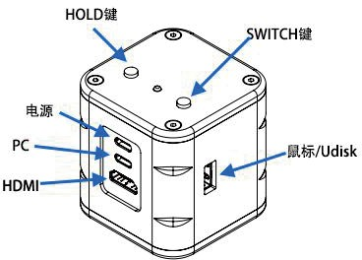
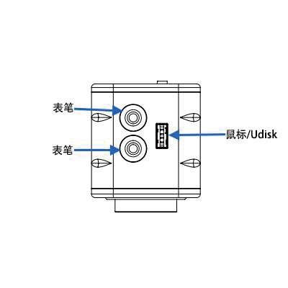
HOLD key
OFF/Channel key
Probe
Power supply
Mouse/Udisk
Mouse/Udisk
Probe

Overview of Built in System Interface
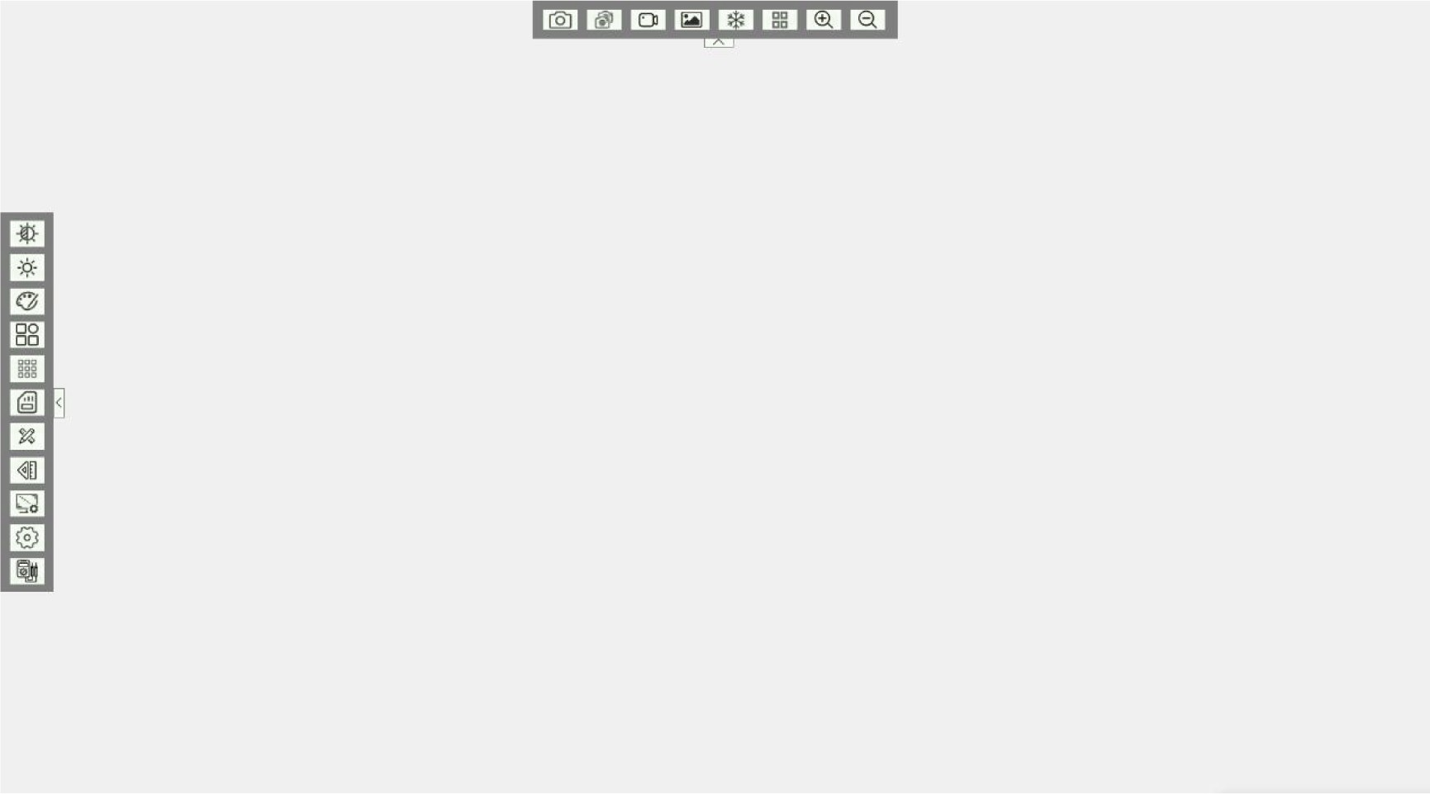

- System menu

  - Introduction to the Left Menu

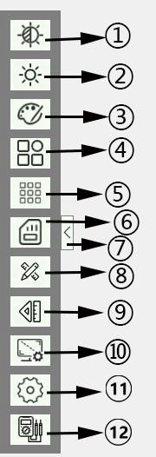
White Balance Menu Button Exposure menu button
Color Adjustment Menu Button Other Function Menu Buttons Grid Line Menu Button
Storage menu button
Hide and expand buttons in the left menu area Calibration menu button
Measurement menu button Resolution Menu Button
Set menu button
Menu button for multimeter

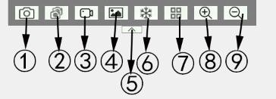
Introduction to the upper menu
① Photo function button
② Continuous photo menu button
③ Video recording function button
④ Picture Gallery
⑤ Hide and expand buttons in the upper menu area
⑥ Freeze function button
⑦ Four screen function button
⑧ Screen zoom button

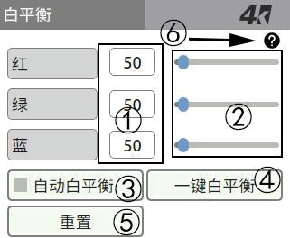
System Operation Guide
White balance
Red

Green
Blue
One-click white balance
Reset
Automatic white balance
  - Left menu button guide
    - White Balance Menu
① White balance function numerical display area (red range (0~255), green range (0~255), blue range (0~255)).
② Sliding bar function numerical adjustment area (can be adjusted by clicking the slider or hovering the mouse over the scroll wheel).
③ Automatic white balance selection button (with a check mark to select automatic white balance, otherwise it will not be selected. It is recommended
to turn on automatic white balance when observing).
④ One click white balance button (disabled when automatic white balance is selected, click when not selected, set to the current optimal white balance value).
⑤ Reset all white balance parameters and enable automatic white balance.
⑥ Open the operating instructions.

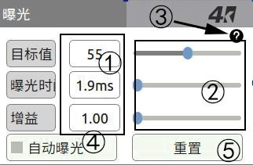

    - Exposure menu
Exposure
Gain
Reset
Automatic exposure
Exposure time
Target value
① Exposure function numerical display area (target value range (10~255), exposure time range (0~40ms), gain range (1~16)).

② Sliding bar function numerical adjustment area (can be adjusted by clicking the slider or hovering the mouse over the scroll wheel).
③ Open the operating instructions.
④ Automatic exposure selection button (with a check mark to select automatic exposure, otherwise it is not selected. It is recommended to turn on automatic exposure during observation. When automatic exposure is turned on, the exposure time and gain cannot be adjusted; when automatic exposure is turned off, the target value cannot be adjusted).
⑤ Reset the exposure target value and enable automatic exposure.

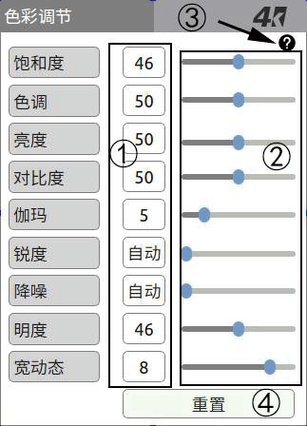
    - Color Adjustment Menu
Color adjustment

Saturation
Brightness
Contrast
Sharpness
Noise reduction

Lightness
Wide dynamic range
Reset
Automatic
Automatic
Gamma
Tone
① Color adjustment function numerical display area (saturation (0~100), hue (0~100), brightness (0~100), contrast (0~100), gamma (1~15), sharpness (29~100), noise reduction (31~64), brightness (0~100), and wide dynamic range (0~15)).
② Sliding bar function numerical adjustment area (can be adjusted by clicking the slider or hovering the mouse over the scroll wheel. When the sharpness value (noise reduction value) is equal to the minimum value, automatic sharpness (automatic noise reduction) will be turned on).
③ Open the operating instructions.
④ Reset all values for color adjustment.

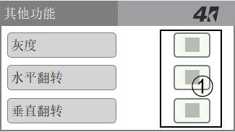
    - Other Function Menu
Other functions Gray scale
Horizontal ﬂip
Vertical ﬂip
① Each function selection button (monochrome, horizontal flip, vertical flip, select to turn on the left function, otherwise it will not be turned on).

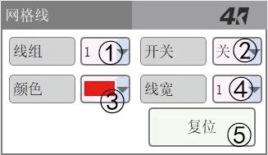
    - Grid Line Menu
Grid line
Wire assembly
Switch
Colour
Line width
Reset
① The selection of grid line numbers is 1-8 (click to select or hover the mouse scroll wheel to select).
Close
② Select the grid line display status for the current sequence number (click to select or hover the mouse wheel to scroll to select).
③ Select the color of the grid lines for the current sequence number (click to select or scroll with the mouse to select).
④ Select the line width of the grid line with the current number (click to select or scroll with the mouse to select).
⑤ Reset the position of all gridlines.

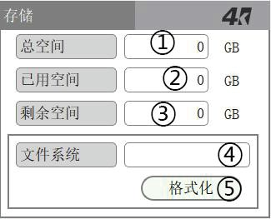
    - Storage Menu
Storage
Total space

Used space

Remaining space
File system
Format
① Display of total space value
② Used space numerical display
③ Remaining space value display
④ Current file system display
⑤ Format USB button

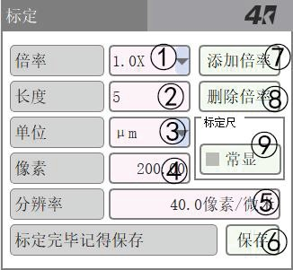

    - Calibration menu
Calibration
Add multiple

Deletion multiplier
µm
Always visible
Remember to save after calibration is completed Save
40.0 pixels per micron
Resolution
200.00
Pixel
Unit
Calibration ruler
Length
Magniﬁcation
① Selection of calibration magnification (click the drop-down button or hover the mouse to scroll). Attention: The calibrated magnification may not be accurate, please modify it yourself if necessary.
② The size of the calibrated object (click to enter the actual size).
③ The unit of size for the calibrated object (click to select or hover over the mouse to select).
④ The pixel size of the calibrated object (when the ruler is displayed, the mouse moves the two endpoints of the ruler to adjust the pixels).

⑤ The pixel size per unit of the calibrated object.
⑥ Save button (save after calibration).
⑦ Add calibration magnification button (after adding, custom magnification will be automatically added in the magnification selection bar).
⑧ Delete calibration magnification button (the first five calibrations can only be changed and cannot
be deleted).
⑨ Is the scale constantly displayed button (when selected, the scale is displayed when switching menus; if not selected, the scale is hidden when switching menus).

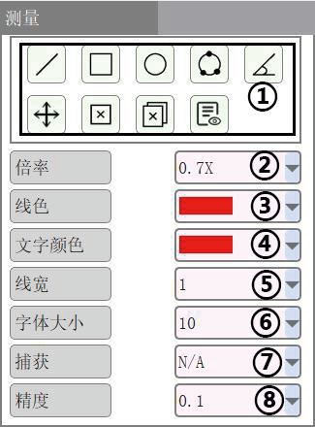
3.1.8. Measurement menu
Measurement
Accuracy
Capture
Font size
Line width
Text color
Line color
Magniﬁcation
① Measurement operations (from left to right, top to bottom) are as follows: draw a line (press and move after selecting), draw a rectangle (press and move after selecting), draw a circle (press and move after selecting), draw a three-point circle (click on three points after selecting), draw a three-point angle (click on three points after selecting),
move (select and click on the graphic boundary to move as a whole, click on the active point to change the size), delete individually (select and click on the graphic element to be deleted), delete all (select and confirm to delete all graphic elements), table (display information about all graphic elements that have been drawn after selecting, click the export button if you want to export data).
② Magnification selection (click the drop-down button or hover the mouse to scroll and adjust the magnification).
③ Line color selection (click the drop-down button or hover the mouse to scroll and adjust the line color).
④ Text color selection (click the drop-down button or hover the mouse to scroll and adjust the text color).
⑤ Line width selection (click the drop-down button or hover the mouse to scroll and adjust the line width).
⑥ Font size selection (click the dropdown button or hover the mouse to scroll and adjust the font size).
⑦ Capture range selection (click the drop-down button, or hover and scroll
with the mouse to adjust the capture range, the first option is to turn off this function).
Function introduction: When drawing graphic elements, the nearest valid point will be automatically found based on the size of the capture range. If found, the mouse will move to that valid point. You can search for effective points again by moving.
⑧ Element precision selection (click the drop-down button, or hover and scroll with the mouse to adjust element precision).

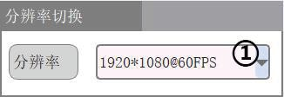
3.1.9 Resolution Menu
Resolution switching
Resolution
① Screen resolution selection (click the dropdown button, or hover and scroll with the mouse to switch resolution).
Note: The same resolution will not switch.

    - Setting menu
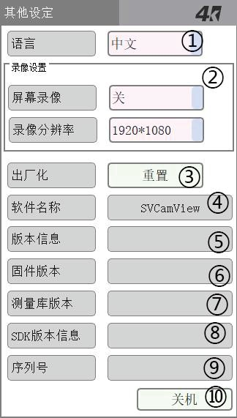
① Language selection (click the drop-down button or hover the mouse to scroll and select a language and switch).
Other settings
Chinese
Screen recording Close

Video resolution

Reset
Version information
Shut down
Serial number
SDK version information
Measurement
library version
Firmware version
Software name
Factory-made
Video recording Settings
Language
② Video recording settings
- Screen recording switch (click the dropdown button or hover the mouse to switch on/off the function)
- Video resolution switching button (click the drop-down button or hover the mouse to switch video resolution. Note: After enabling screen recording, the video resolution automatically switches to 1920 * 1080 and cannot be switched)
③ Restore factory settings.
Attention: After restoring the factory settings, the specific reset
contents are as follows:
- Reset the exposure parameters to default settings and enable automatic exposure.
- Reset the white balance parameters to default settings and enable manual white balance.
- Contrast, saturation, brightness, sharpness, noise reduction, hue, and gamma are all set as default parameters.
- Screen flipping, freezing, monochromatization, and quad screen do not participate in factory restoration.
- Reset the color of the measurement attribute to red, the line width to 2, the font color to red, the font size to 10, the accuracy to 0.01, and the capture to 10px.
- Reset the grid line colors for all groups, set all line statuses to "off", set all line widths to "1", and reset all line positions
④ Program name information.
⑤ Software version information.
⑥ Firmware version information.
⑦ Measure library version information.
⑧ SDK version information.
⑨ Serial number information.
⑩ Shutdown button

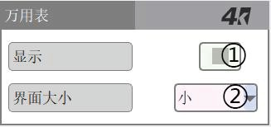
    - Multimeter Setting Menu
Multimeter
Small
Interface size
Display
① Display button for multimeter data interface (check to display multimeter value interface)
② Multi meter data interface size switching (click the drop-down button or hover the mouse to switch interface size)

  - Upper Menu Button Guide
    - Photo button
When the system detects that a USB flash drive is inserted and the available capacity is sufficient, clicking on it will start taking photos. The upper left corner will prompt that it is saving, and during this period, the photo button cannot be clicked again. The photo button can only be clicked again after the top left corner indicates a successful photo. After successful saving, you can enter the gallery to view the photos taken.

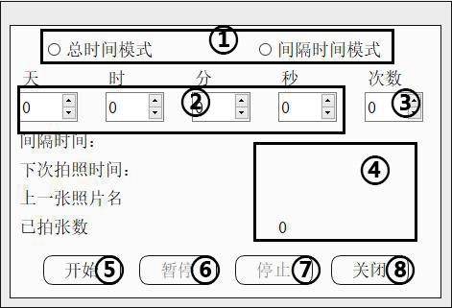
    - Timed Photography Menu
Day
Total time mode
Hour
Interval time mode
Divide
Second
Number of times
Interval time:
Next photo taking time:
Previous photo title
Number of photos taken
Start
Pause
Stop
Close
① Mode selection.
Mode introduction: (1) Total time mode:
Take multiple photos according to the set number of times within the set time.
(2) Interval time mode: Use the set time as the interval and take multiple photos according to the set number of times. (Note: The minimum interval time should not be less than 2 seconds.)
② Set the time (mouse click or hover scroll to adjust the time).
③ Set the number of photos taken (adjust the number of photos by clicking or hovering the mouse).
④ Partial information during the photo taking process (interval time, next photo time, previous photo name, number of photos taken).
⑤ Start taking timed photos.
⑥ Pause scheduled photography (click again to continue).
⑦ Stop taking timed photos.
⑧ Close the timed photo menu (if taking a timed photo, the photo will end and the menu will be closed).

3.2.3 Video recording button
When the system detects that the USB flash drive is inserted and the available capacity is sufficient,
click the recording button to start recording. At this time, the button status is, and the recorded time and flag are displayed in the upper left corner. After clicking the recording button again, the recording will end. At this point, the top left corner will display 'saving' and the recording button cannot be clicked. After saving, the upper left corner shows that the recording was successful and the recording button is restored. At this point, you can record again. If the USB flash drive space is less than 50MB during recording, the recording will automatically stop. If the recording time reaches twenty minutes, stop the recording and save it. After t he save is complete, automatically start recording and continue recording until the USB flash drive space is less than 50MB. (Note: unplugging the USB flash drive during the recording process may cause the video file to be damaged and unable to be opened).

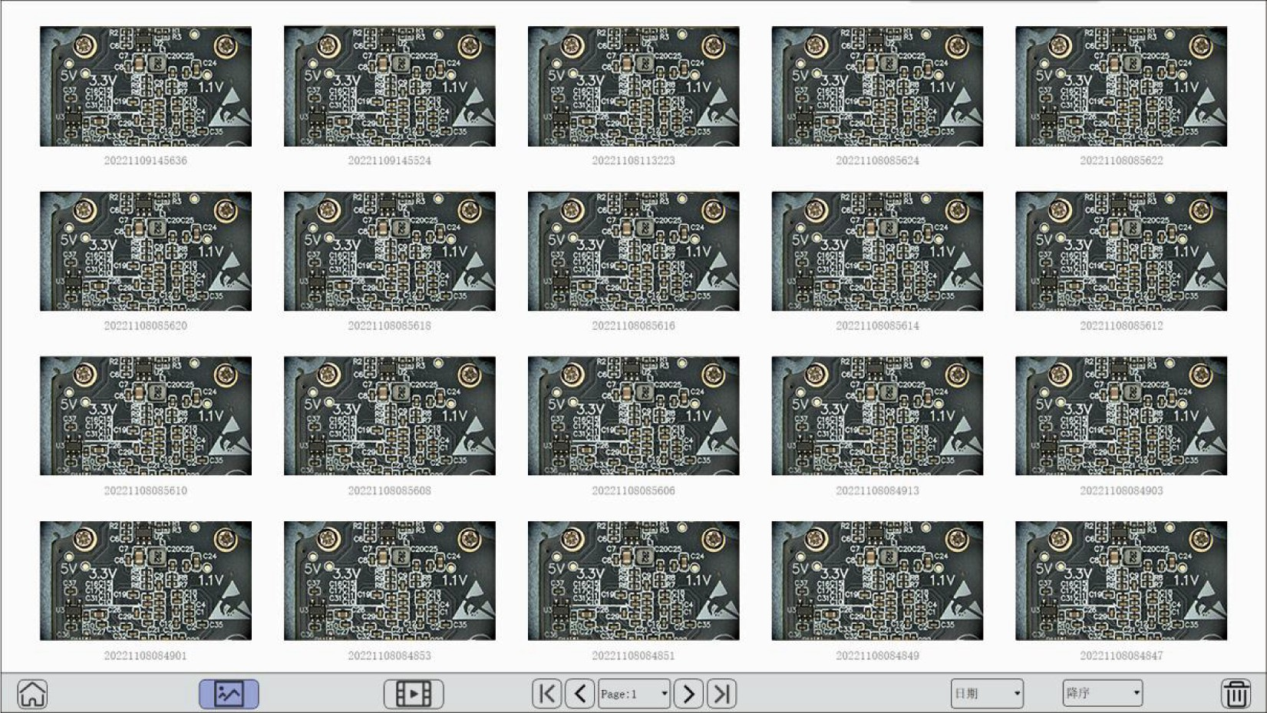
日期
降序

    - Library Button
When the system detects that a USB flash drive is inserted and not recording, you can enter
the gallery to view photos and videos.

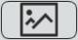 Switch to image preview.
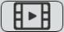 Switch to video preview. Appear above each video  Remind that the current files are all video files.  After clicking, the current preview page will jump to the first page.
 After clicking, the current preview page will jump to the last page.
 After clicking, the current preview page will jump to the previous page.  After clicking, the current preview page will jump to the next page.
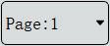 Display the page number of the current page. After clicking, a dropdown menu will appear, selecting the page you want to jump to.
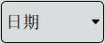 Display the current sorting criteria, which can be sorted by name or by file time.
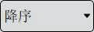 Display the current sorting order, which can be selected as ascending or descending.
 Select an image or video and click delete to delete it. You can also select multiple options and click 'delete' to perform batch deletion.
 Exit the gallery.



View image: Double click on the image with the mouse to open it, or right-click on the file to bring up the menu and click Open to open the image. After opening, the control bar displays the current file name. click Switch to the previous image. click Switch to the next image. click Exit to the gallery.



View video: Double click the video with the mouse to open it, or right-click and select the menu to open the video. After opening, the control bar displays the current file name. After opening the video, it automatically starts playing, At this point, the play button switches to


Click again Pause the current video and switch the play button to click Switch to the previous video and play it automatically.
click Switch to the next video and play automatically click  Stop the current video click Exit to the gallery.
View file information
Right click on the file you want to view, bring up the menu bar, and click on 'Details' to display the detailed information of the current file.
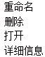
Rename Delete Open
Detailed information

    - Freeze button
Freeze the image displayed by the current camera. (Note: Magnification, reduction, horizontal flipping, vertical flipping, monochromatization, and quarter screen cannot be performed in the current state.
Freezing will be automatically turned off when opening the gallery.)

    - Four screen button
After clicking, turn on the quad screen. Left click on one of the split screens to freeze it, and click again to unfreeze it. Click on the quad screen again to exit the quad screen. Automatically exit the four screen mode after opening the gallery (note: measurements cannot be taken after the four screen mode is turned on).

    - Magnification button
Magnification: Increase the camera's magnification. The center of enlargement is determined by the position of the previous wheel enlargement. If the wheel has not been enlarged, it will default to center enlargement. (Note: The magnification is reset after opening the gallery) The mouse wheel can also zoom in.

3.2.8. Magnification reduction button
Magnification reduction: Reduce the camera magnification. The center of reduction is determined by the position of the previous enlargement, and further reduction will be determined by the position of the previous enlargement, and so on. (Note: The magnification is reset after opening the gallery) The mouse wheel can also reduce the magnification.

- Frequently Asked Questions
- When automatic exposure is turned on, the light source is unstable, and there may be fluctuations in
exposure time and gain, which is a normal situation.
- In the automatic white balance module, changes in the image can cause fluctuations in the values
of red, green, and blue, which is a normal phenomenon.

- Common troubleshooting methods
- The machine does not work after connecting to the power supply:
Check if the power cord is connected properly and if the interface connected is a DC5V 2A interface. Check if the connected voltage is correct.
When connecting to a computer, connect the DC5V 2A interface to a power adapter and the PC port to the computer USB port.

- Display exception:
Please check if all connecting wires are in good contact. Is the monitor in HDMI input mode.
Perform a factory reset on the camera.
If your issue cannot be resolved, please contact us promptly.

- Precautions
Our company reserves the right to improve and adjust product functionality, specifications, design, and related content. When there are differences between the content of the product manual and the actual product, the actual product shall prevail. The above adjustments will not be notified separately. We suggest that you carefully check the product status before use. If you have any questions, please contact our customer service for consultation.



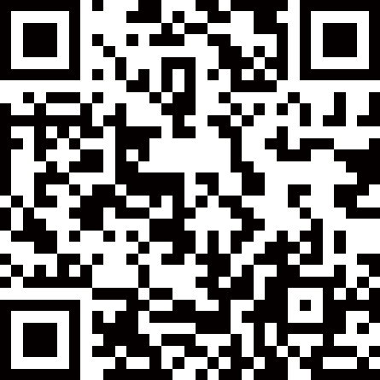

Guangzhou Sunshine Electronics Technology Co.,Ltd. Executive standard: Q/XXDZ 046-2023
Address: 5th Floor, Building 3,Liando U valley,No.105, Shilong North Road,Nanhai District, Foshan City Website: www. exinxun. com

